Tasks
Objective Questions
1.What is the total no. of attributes present in the data?
Observations: The IT Ticket Analysis work book consists of 2 worksheets, viz, Ticker and IT Agents Ticket have 12 attributes while IT Agents has 8 attributes. So, in total after combining the attributes of both the worksheets, there are 20 attributes out of which Agent ID, Agent Name, Age, is common between both of them and hence There are 17 unique attributes
Formula used: =COUNTA(Tickets[#Headers])

2. Which columns have inconsistent or missing values, and what is the count of such values?
Observations: None of the columns in either of the worksheets have any missing values. However, there are some column names/values with unknown words or incorrect spellings.
The word Fecha is in Spanish language for Date and can be renamed as Date for understanding. Two of the values in Severity column has incorrect spell tags, viz. Unclasified and Mayor which should be renamed to Unclassified and Major. Using Find and Replace inbuilt tool, 356 values got updated to Unclassified and -1836 values to Major. Two of the values in Priority column has incorrect spellings, viz. Unassiged and Mid which should be revised to Unassigned and Medium. Mid has to be renamed as this is short form for Middle. All the priority has values like Low and high, so eventually, it should be Medium. Using Find and Replace inbuilt tool, 29410 values got updated to Unassigned and 15845 values to Medium.
Changed the datatype of columns Employee ID, Agent ID, Resolution Time (Days) and Satisfaction rate to Numbers.

Formula used: =COUNTBLANK(Tickets[[#All],[ID Ticket]])
Find () and Replace ()

3. What is the average daily ticket volume over time?
Observations:
The average daily ticket volume based on time is 53.37. We find this using Average () and CountA () functions.
53 tickets solved by agents on a daily basis. Total unique days: 1827. Total tickets: 97,498.
Formula used: =COUNTA(Tickets[ID Ticket])/COUNTA(O2:O1828)
4. What is the distribution of ticket categories (e.g., Login Access, System, Software)?
In given data set we observed that there are 3 categories of tickets (i.e. System, Software, Hardware, Login Access) we get the results distribution of ticket category by using Pivots table and insert column bar chart Visualization: -

Observation: -
From this Column Bar graph chart, we observed that there is the highest number of tickets raised by employees in system category (39002 tickets) after login access (29193 tickets), software (19570 tickets) and least one is hardware type (9733 tickets).

5.How many tickets has each agent handled?
The number of tickets each agent handle obtained by using pivot table, column chart
Visualization: -

Observation: - After seeing pivot table, we conclude that mostly 88% agent handle ticket within range (1900-2030) tickets and rest of 12 % agent handle ticket within range (1800-1900) tickets
6. How can you extract the domain from the email addresses in the IT Agents sheet?
Observations: -
After seeing the dataset on the IT Agent sheet, first we insert a new column named as email_domain. Then after that, we use RIGHT(), FIND(), LEN() functions on the same column cell to extract unique domain from email.
Formula used: =RIGHT([@Email],LEN([@Email])-FIND("@",[@Email]))
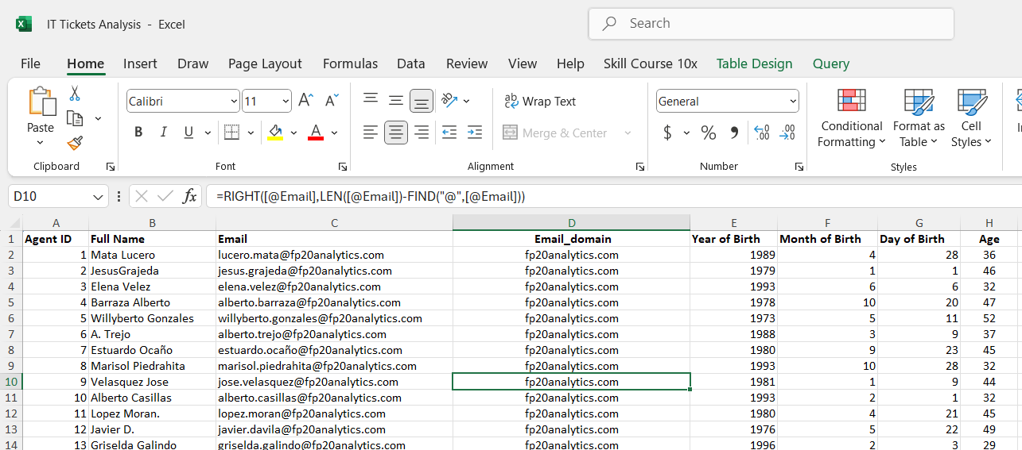

Formula
7.How can you find the full name of an agent given their Agent ID?
Observations: -
We can find the full name of the given Agent ID in both sheets (IT Agent, Tickets) using VLOOKUP (), XLOOKUP (), Index+ match () functions.
So here I used the VLOOKUP () function to extract the full name in the ticket sheet using Agent ID.
Formula used: =VLOOKUP([@[Agent ID]],IT_Agents[#All],MATCH(IT_Agents[[#Headers],[Full Name]],IT_Agents[#Headers],0),0)
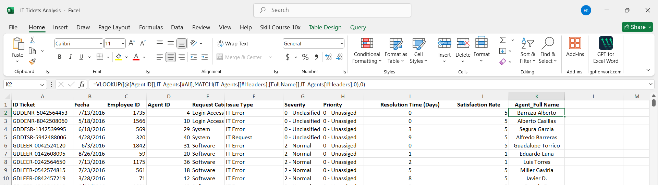

Formula
8. What is the count of each issue type (e.g., IT Error, IT Request)?
By help of pivot and bar graph we find the count of different type of issue, in pivot we add issue type in a Row, count of IT Tickets in values to get the values
Visualization: -

Observations: -
After seeing above chart conclude that IT request portion is up to 75.1%, 73220 requests and rest of IT error is 24.9%, 24278 request in this chart
9. What is the daily average resolution time for tickets?
Observation: -
The average of daily resolution time for tickets is 4.5 days I get the answer of that by using average function
Formula used: =AVERAGE(Tickets[Resolution_time Updated])
10. How has the volume of tickets changed over time?
Observation: - The volume of tickets changing over time is 17.55 tickets. We get this value by Stand Deviation function =STDEV.S(AF2:AF1828) and conclude that 17 tickets change on a daily basis.
Visualization:

Observations: -
We get monthly trends of ticket volume using pivot table and line chart highest ticket volume in Oct Month, and Lowest ticket volume in Jan month.
11. What is the average age of the IT agents?
Observations: - The average age of an IT agent is found by subtracting year of birth by current year so we get the difference year count as age number in the age column. Here I used Average (), Text (), Today () function to retrieve the average age.
Average age: 40.4 Years
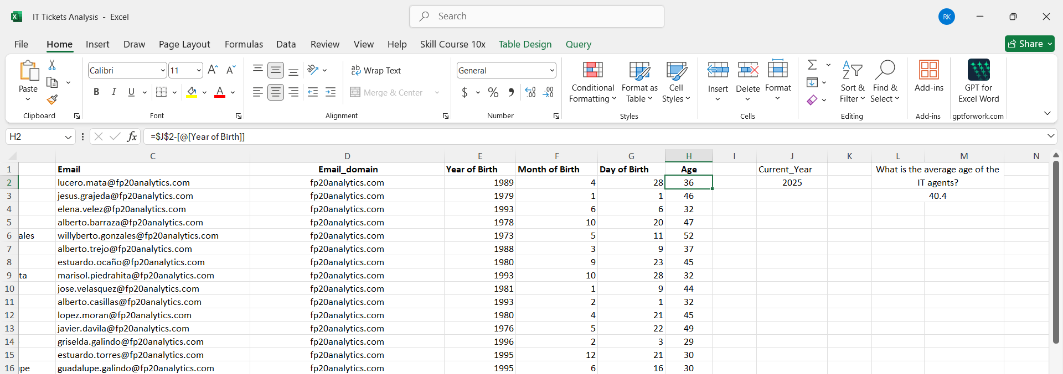
Formula

Formula used: =AVERAGE(IT_Agents[Age])
12. Is there a correlation between the severity of issues and the resolution time?
There is no correlation between the severity of issues and the resolution time as the value found using CORREL function is ‘-0.0212’ While finding correlation, unclassified severity tickets and the tickets which took 0 days to get resolved have being ignored.
Formula used: =CORREL(P2:P97499,Tickets[Resolution_time Updated])

13. How many categorical columns are there in the data? [Search about categorical and continuous data, and try to answer this question
There is total 13 columns which is categorical (Ticket ID, Employee ID, Agent ID, Agent Full Name, Request Category, Issue Type, Severity, Priority, Operation Time, email, Month of Birth, Day of Birth, Year of birth, Age)

